Presenters
Fr. Ron Barusefski
A priest of the Eparchy of Passaic and Director of Human Formation at SS. Cyril & Methodius Seminary. He has a licentiate in canon law from Catholic University in Washington and a doctorate in canon law from the Pontifical University of St. Thomas Aquinas in Rome.

Amanda Singel
Amanda received a BA in Studio Arts from the University of Pittsburgh. Currently, she is the Assistant to the Director of the Office of Religious Education and the Business Manager for the Eastern Catholic Eparchial Directors of Religious Education (ECED).

Fr. Robert Jager
Pastor of two parishes and Vocation Director for the Eparchy of Parma. Fr. Robert has studied at several theological institutions including the Pontifical Gregorian University in Rome. He contributed to his eparchial faith formation series “I Believe” and directed the Women’s Retreat for his eparchy.

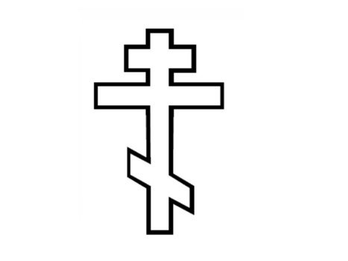

Fr. Robert Pipta
Rector and Instructor of Liturgical Practicum at SS. Cyril & Methodius Seminary. A priest of the Eparchy of Phoenix and served parishes there for 20 years. He was also Eparchial Director of Vocations for his eparchy and is a member of the Intereparchial Commission for Sacred Liturgy.

Dr. Joan Grossman

Dr. Joan Grossman, professor in the Science department at the University of Scranton and Eparchy of Passaic Project Coordinator for the synod. She is a member of St. Nicholas of Myra Byzantine Catholic Church in Swoyersville, PA.

Save the date
Metropolitan Assembly
“Living Our Faith…Moving Forward…Appreciating Our Past”
November 3, 4, 5, 2023
St. Mary Byzantine Catholic Church
Hillsboro, NJ

Eparchial Assembly
2023

Synodal Synthesis:
A Mandate, Not an Option

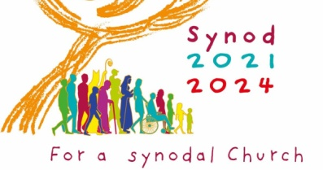

In-person event sponsored by the Archeparchial
Office of Religious Education

Saturday, April 29, 2023

St. John the Baptist Cathedral
Munhall, PA
Purpose
All four eparchies in the Metropolia participated in the National Synthesis of the People of God in the USA for a Synodal Church: Communion, Participation & Mission.

Eparchies utilized a variety of opportunities for engaging people in the process, including local gatherings, listening sessions and surveys.

The purpose of this Assembly is to hear the responses from all four eparchies. Together we will discern the common joys, hopes and wounds. With the help of the Holy Spirit, we will know how to move forward.

Go, therefore, and make disciples of all nations, baptizing them in the name of the Father, and of the Son, and of the Holy Spirit, teaching them to observe all that I have commanded you. And behold, I am with you always, until the end of the age. (Mt. 28:19-20)

Schedule

9:00 – Registration & Coffee
9:45 – Opening Prayer
10:00 – A Review of the Synodal Process
10:10 – Discipleship in Our Church:
Past, Present & Future
Fr. Ron Barusefski
10:50 – Break
11:00 – Archeparchy of Pittsburgh
Amanda Singel
11:30 – Eparchy of Parma
Fr. Robert Jager
12:00 – Lunch
12:45 – Eparchy of Phoenix
Fr. Robert Pipta
1:15 – Eparchy of Passaic
Dr. Joan Grossman
1:45 – Break
2:00 – Group Process with
Guided Questions
2:30 – Feedback
3:00 – Final Remarks/Departure

REGISTRATION FORM

Eparchial Assembly

Saturday, April 29, 2023

St. John the Baptist Cathedral, Munhall, PA PLEASE PRINT

Name (s):______________________________________________________

Email ________________________________________________________

Parish:_____________________________Pastor______________________

Early Registration Fee before April 1, 2023: $50 per person

Registration Fee after April 1, 2023: $65 per person

DEADLINE: April 22, 2023 – NO REFUNDS

Please make checks payable to Office of Religious Education

3605 Perrysville Ave., Pittsburgh, PA 15214

Questions: 412-322-8773 mdobos1@gmail.com

